

Practices for Secure Software Report

Table of Contents
Document Revision History 3
Client 3
Instructions 3
Developer 4
1. Algorithm Cipher 4
2. Certificate Generation 4
3. Deploy Cipher 4
4. Secure Communications 4
5. Secondary Testing 4
6. Functional Testing 4
7. Summary 4
8. Industry Standard Best Practices 4

Document Revision History

Version | Date | Author | Comments
1.0 | 6/21/2026 | Kyle Gilbert

Client



Developer
Kyle Gilbert

Algorithm Cipher

For security reasons the Artimis Financial group needs to encrypt data to ensure that it can not be read in transit. Financial information, if intercepted, could be used to make unauthorized withdrawals from accounts of customers. For an encryption method, I would recommend AES as an encryption algorithm. I would also recommend the larges size available of 256 to ensure further security.
AES-256 is like any good tool. It can be problematic if not implemented properly. If the handling of keys is sloppy, I could foresee issues. If the key was hardcoded, it is possible that the key would be completely irrelevant and allow full access to the data.

There are regulations to consider when handling financial information. The PCI SSC is intended to ensure that credit card information is handled properly. The require that networks are secure and credit card information is encrypted. There is also the BSA of 1970. This act is meant to ensure that financial institutions cannot be utilized for money laundering.

Algorithms like AES-256 utilize a system that uses mathematics formulas to garble the message. This would be problematic, as eventually someone needs to read the information contained to work with it or access a bank account. This is where the key comes in. When someone with the key access the encrypted information, it can be viewed. This is why careful consideration must be used in coding information regarding keys as it needs to be kept secret from all but the intended recipients.
It is difficult to say what the best cypher is. You could encrypt data using a key that is gigabytes long and make it near impossible to crack (barring quantum computing), but even with the right key (which is now huge) it would take a lot of time to utilize. It also is determined by what task you are doing. It is worth noting that some hardware comes with the ability to code/decode with built in functionality, making it cheaper and easier to implement.

A hash function exists to ensure that data has not been altered from the time it was created. If a key is created with a hash and the key itself is altered. This can be checked when it gets received. If the key does not match the hash, it is known that there was either corruption, or alteration of one of the files.
The use of random numbers is used to generate keys. This would allow programmers to create completely unpredictable keys, but there’s really no such thing as a truly random number. This means that even when functions try to utilize the computers ability to get a number out of thin air, this can be predictable, and keys/hashes can be cracked.

Symmetric keys are used via a private key. This key needs to be delivered in a way that will not allow others to see, which can be difficult. Once the key is safely delivered, it makes for a reliable and fast network. Asymmetric cryptography is when public keys and a single private key is used to unlock data that is locked by the public keys.
by radio (completely public), and the only way to read it is to have the proper settings on both ends. The birth of the internet brought rise to the need to encrypt digital traffic. This brought the Data Encryption Standard.

Certificate Generation

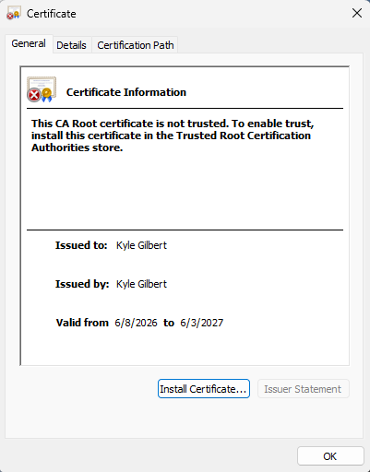

Deploy Cipher
Screenshot of the Hash generated by the code

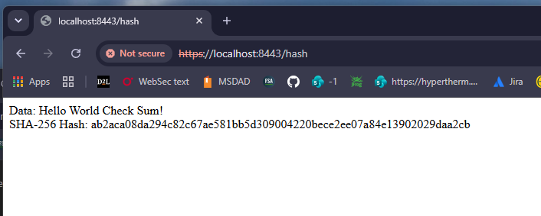

Secure Communications
The above image shows the HTTPS with a red line indicating that it is HTTPS, but a self signed certificate.
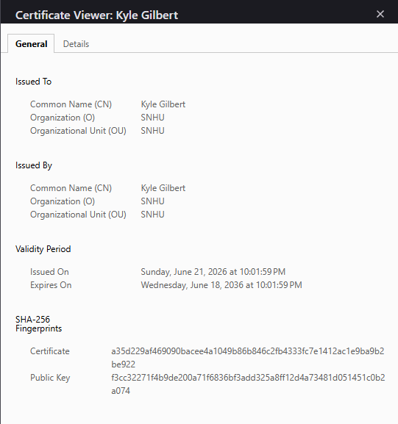

Secondary Testing
Here is a screenshot of the build running without errors
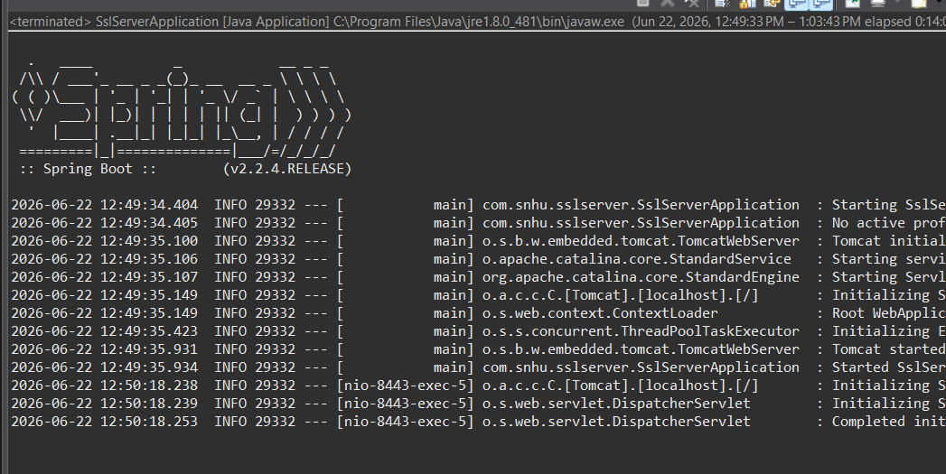
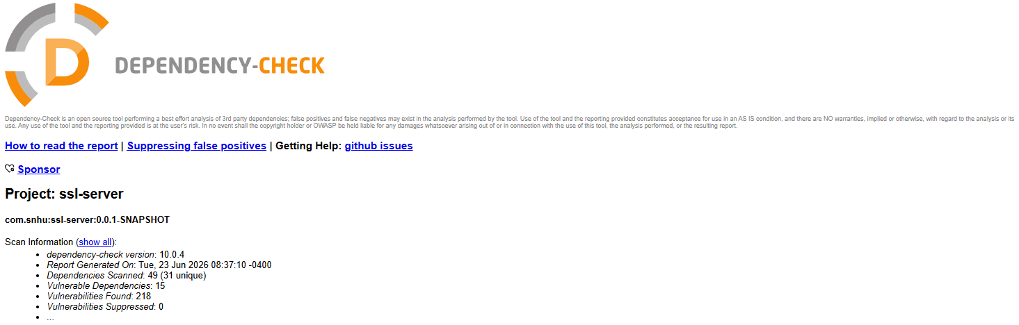

Functional Testing
Here is the refactored code with the added ServerController class for generating the hash.

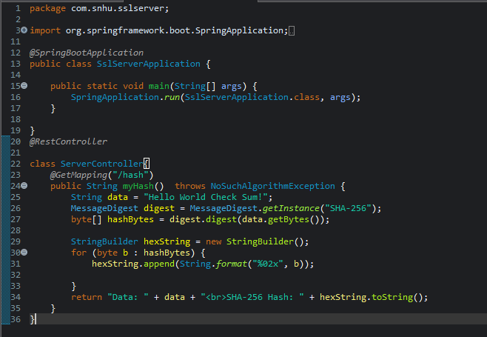

Summary

In this database, we addressed several vulnerabilities. We observed that HTTPS was not being utilized. We added that functionality to ensure secure data transmission. To employ HTTPS we needed to generate a certificate to be authenticated by the browser. The hash function we employed was a SHA-256. This is an industry standard and more than secure enough for financial transactions.

We then ran a dependency check to ensure that we did not introduce any new vulnerabilities with our code. The majority of identified issues were related to outdated third-party libraries rather than the newly implemented functionality. This highlights the importance of maintaining up-to-date dependencies as part of ongoing security management.

The first layer we added was HTTPS. This allows for encrypted communication with TLS. We then needed the self signed certificate to verify the identity before data is transmitted. After this we incorporated a SHA-256 hash function to provide data integrity. We then ran a dependency check as the final layer to ensure nothing more was introduced.

Industry Standard Best Practices

The biggest change we made to meet industry standards is utilizing TLS to switch from HTTP to HTTPS. This allows our data to move without being decoded. Using industry standards we implemented a data integrity function with SHA-256

Using industry-standard can be incredibly valuable to a company to reduce the risk of stolen data and ransomware attacks. This improves confidence of users and keeps companies profitable. Industry-standard practices are time tested and used commonly for this reason.

